|  |
| --- |
| **Experiment No.8** |
| Implementation of Views and Triggers |
| Date of Performance: |
| Date of Submission: |



**Experiment No.8**

**Aim :- Write a SQL query to implement views and triggers**

**Objective :-** To learn about virtual tables in the database and also PLSQL constructs **Theory:**

**SQL Views:**

In SQL, a view is a virtual table based on the result-set of an SQL statement.

A view contains rows and columns, just like a real table. The fields in a view are fields from one or more real tables in the database.

You can add SQL statements and functions to a view and present the data as if the data were coming from one single table.

A view is created with the CREATE VIEW statement.

CREATE VIEW Syntax

CREATE VIEW view_name AS

SELECT column1, column2, ...

FROM table_name

WHERE condition;

SQL Updating a View

A view can be updated with the CREATE OR REPLACE VIEW statement.

SQL CREATE OR REPLACE VIEW Syntax

CREATE OR REPLACE VIEW view_name AS

SELECT column1, column2, ...

FROM table_name

WHERE condition;

SQL Dropping a View

A view is deleted with the DROP VIEW statement.

SQL DROP VIEW Syntax

DROP VIEW view_name;

Trigger: A trigger is a stored procedure in the database which automatically invokes whenever a special event in the database occurs. For example, a trigger can be invoked when a row is inserted into a specified table or when certain table columns are being updated.

Syntax:

create trigger [trigger_name]

[before | after]

{insert | update | delete}

on [table_name]

[for each row]

[trigger_body]

Explanation of syntax:

1. create trigger [trigger_name]: Creates or replaces an existing trigger with the trigger_name.

2. [before | after]: This specifies when the trigger will be executed.

3. {insert | update | delete}: This specifies the DML operation.

4. on [table_name]: This specifies the name of the table associated with the trigger. 5. [for each row]: This specifies a row-level trigger, i.e., the trigger will be executed for each row being affected.

6. [trigger_body]: This provides the operation to be performed as trigger is fired

**Implementation:**

SQL View:

1. Create View:

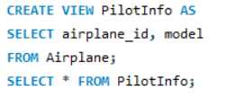



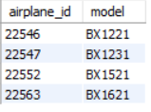

1. Drop View:

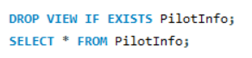



SQL Trigger:

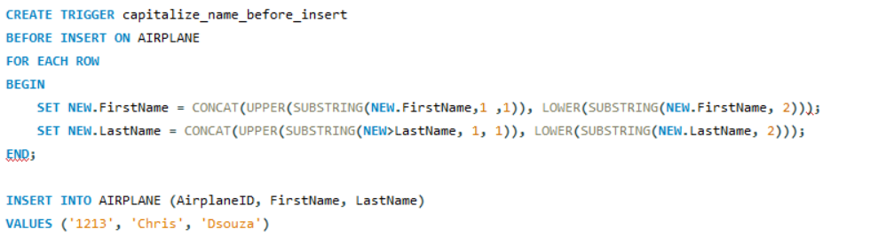

**Conclusion:**

1. Brief about the benefits for using views and triggers.

Ans. Views simplify queries, enhance security, abstract table structures, and optimize performance. Triggers enforce data integrity, audit changes, enforce business logic, and support replication.

.

1. Explain different strategies to update views.

Ans. Updating views can be done directly, by updating base tables, using triggers, or by recreating views. These methods offer varying degrees of control and are applied based on the view's complexity and update requirements.